**SIFT:** Scale Invariant Feature Transforms, is use for object detection in a image, or image search.

Instead of comparing whole object, it stores key points of images which are distinct and unique for example corners. And it stores those keypoints in 128 dimension vector.

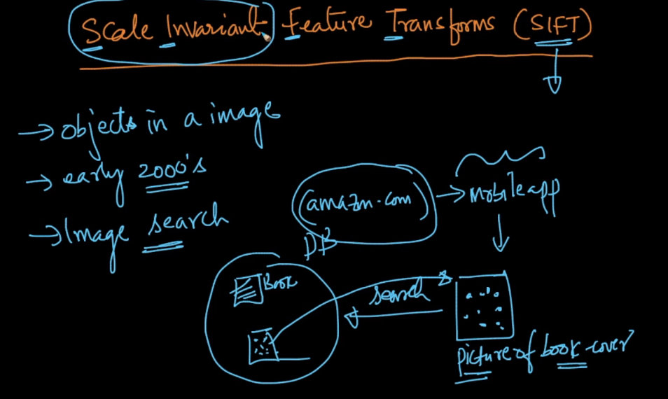

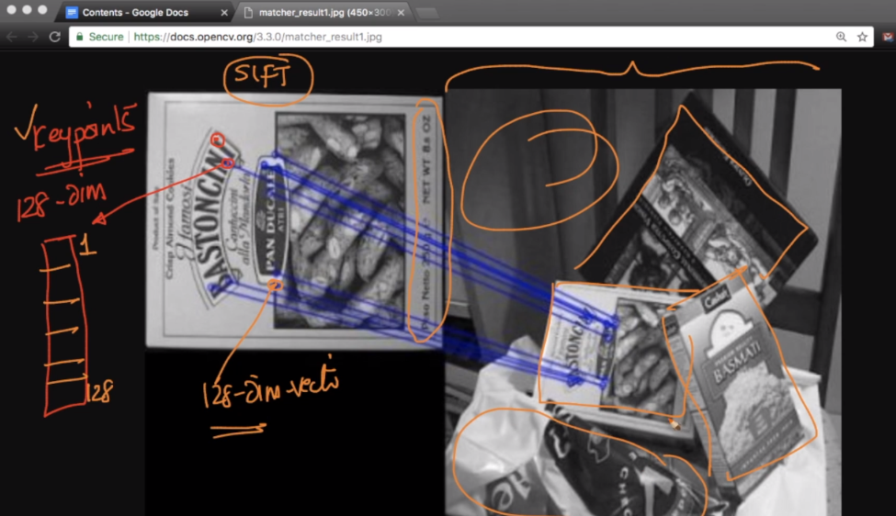

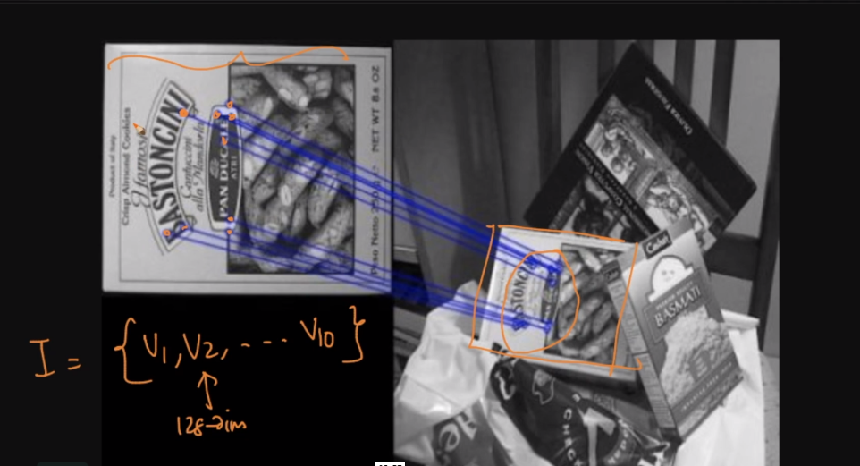

**SIFT is scale invariance and rotational invariance.**

**Scale invariance:** what it means is key points will be preserved even if object size changes.

**Rotational invariance:** it still detect object when the object get’s rotated, that means it is rotation independent.

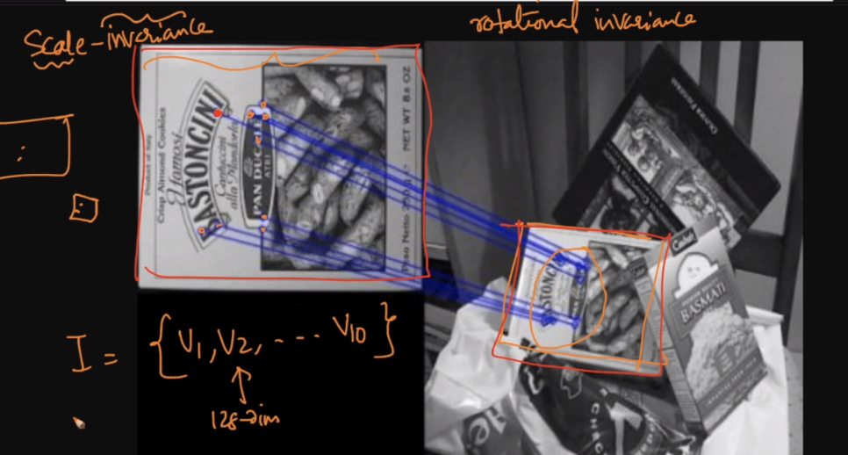

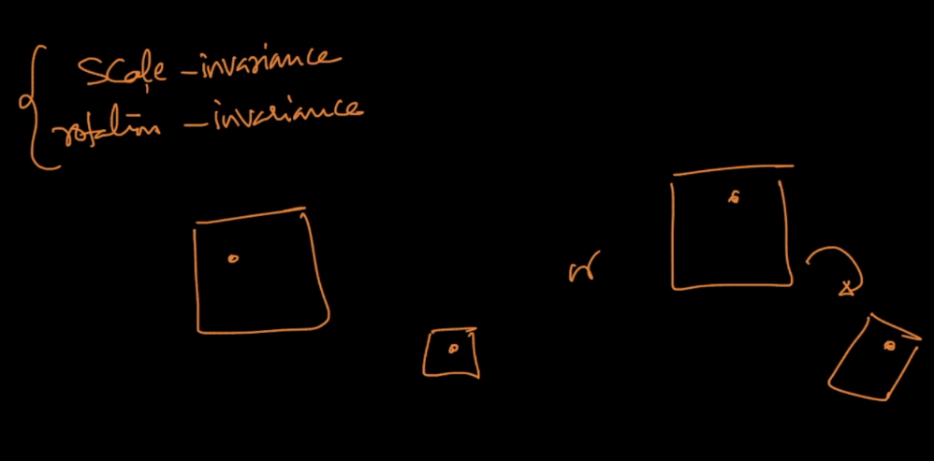

openCV is used to generate features using SIFT.

